CZ P-10 C 9mm Gun Review: Is This Firearm Better Than A Glock?

By
Richard Douglas
Published
November 11, 2021

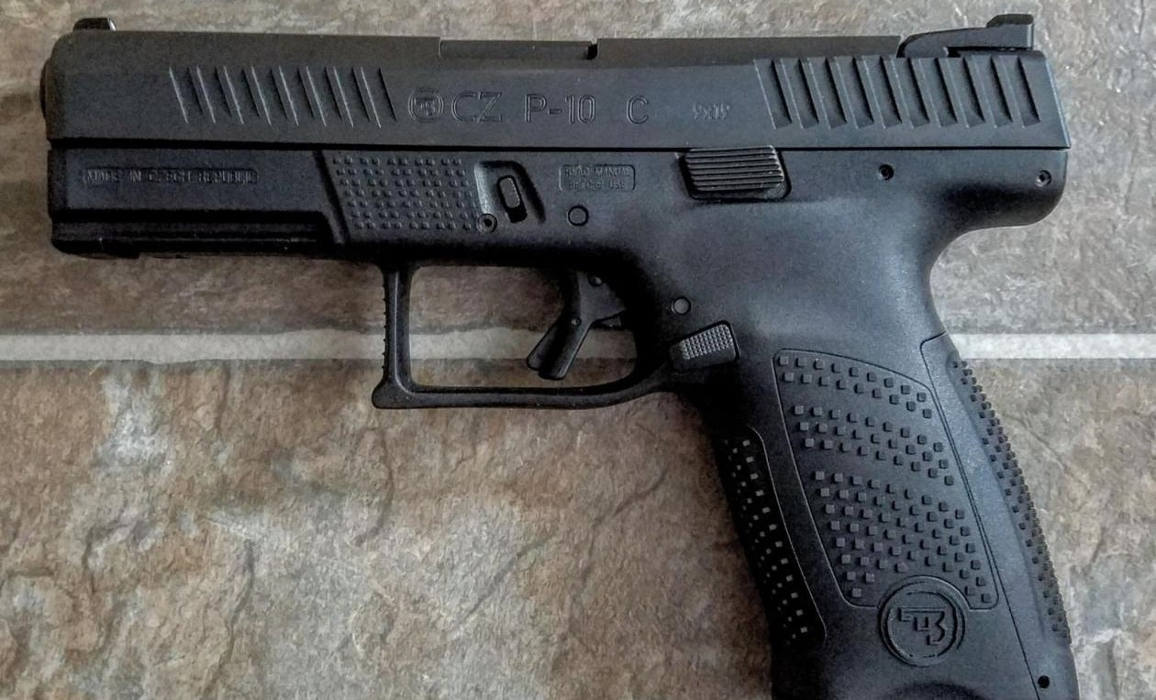
Image: Creative Commons.
CZ has made quite a name for itself. They’ve developed some classic firearms, namely the Scorpion and the newer Scorpion EVO, one of my favorite carbines. I also still use my CZ P-07 for my everyday carry (sorry Glock, I still love you). That was until I heard about the P-10 C. CZ’s striker-fired pistol, configured with concealability in mind.
Will the P-10 C live up to the hype and become my new concealed carry? Read on to find out!
I have to be honest, I think the P-10 C is just alright looking. It’s a little bit too round for my taste. It was actually one of the reasons I ducked the P-10 C and got a P-07 instead. I must say I love that sweet urban grey finish on the lower receiver. But looks do not make the gun. I do wish the slide stop was a smidgen bigger since I’ve become accustomed to my P-07, but that’s just a matter of preference. The grip is also just a little longer than I prefer for carrying concealed. It’s about the same length as a Glock 17. I almost always try to go for the most compact pistols combined with high capacity for effective self-defense and concealment.
Functionally, the P-10 C is spectacular. As is the case for most CZs, shooting feels smooth and flat. The trigger is pretty great for a striker-fired pistol too. The take-up is smooth, the break is clean, and the reset is tactile. No need to swap triggers out here. Recoil is pretty flat, almost imperceptible, at least when you’re actively shooting. In actuality, it’s present but not bad and trivially easy to control with a firm-wristed grip and proper shooting technique.
Reliability was not an issue whatsoever. 1000+ rounds went through this pistol without even a hint of an issue. I put plenty of ammo through the P-10 including steel-cased, regular brass, and my self-defense rounds. All cycled without a hitch. I expected that out of CZ anyway, but it’s always nice to know you have a well-oiled machine ready to go whenever you need it. It is worth mentioning though that I give all my new firearms a little bit of a cursory clean whenever I get them though.
The P-10 C is reasonably concealable. It’s not the smallest compact around, but it’s not going to constantly print with lighter-colored shirts. I carried mine around for about three weeks and change and got pretty comfortable with it. It’s nothing special as far as its size or concealability. The real honest-to-God truth is that the P-10 C is a pistol you buy to feel like you got a performance gun at a budget price. So no, it’s not the best for concealability and it’s probably not replacing my P-07 or my Glock 43X, but it’s a great pistol to carry all the same.

CZ P-10 C: The Final Verdict
The P-10 C is a rock-solid offering from CZ and would be an excellent purchase for anyone that wants to conceal or just own a high-quality firearm. The P-10 C is amazing to shoot, easy to control, and cycles everything. There’s a lot to love here and not a lot to dislike.

